**WORK INSTRUCTIONS FOR** **OPERATION OF BF#2 SCRUBBER UNIT**

**Responsibility: Shift Superintend/Cast house in charge/Furnace In charge**

**Identified Hazards:**

1. BF Gas leakage/Poisoning
2. Fire and Explosion in the gas line
3. Contact with hot water
4. Fall of person
5. Human behavior-Nonuse of PPE
6. Human Behavior-Improper house keeping
7. Human behavior-Not carrying CO detector
8. Burns due to contact with hot water/surface

**Significant Aspects:**

1. Usage of water/spillage of water
2. BF Gas leakage
3. Fire &Explosion

**Procedure for Scrubber operation**

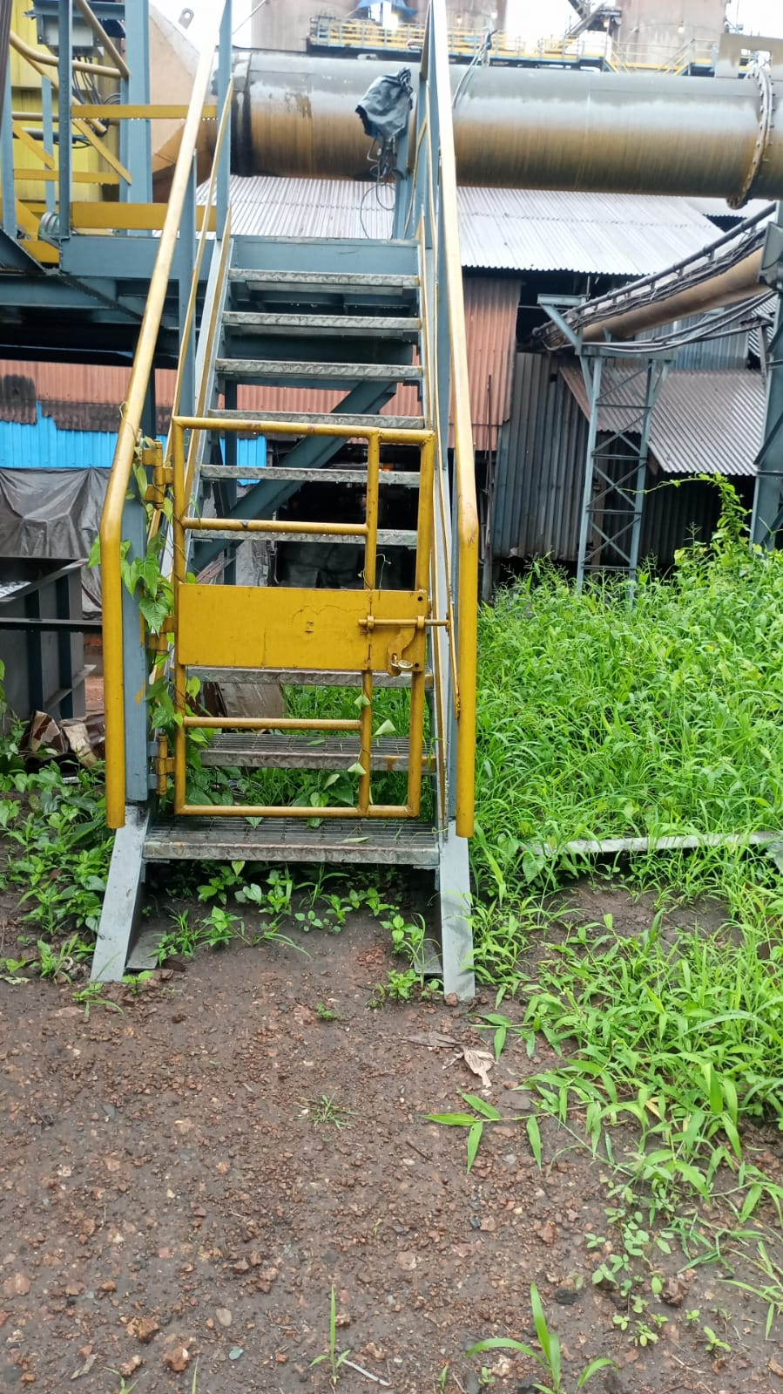

Access to Scrubber Unit

1. **Taking Scrubber In line:**
   * 1. Purge the Scrubber unit thoroughly with steam
     2. Drop HBS water seal and close all individual relief valves
     3. Start BF2 GCS pump, ensure all individual water valves are kept open.

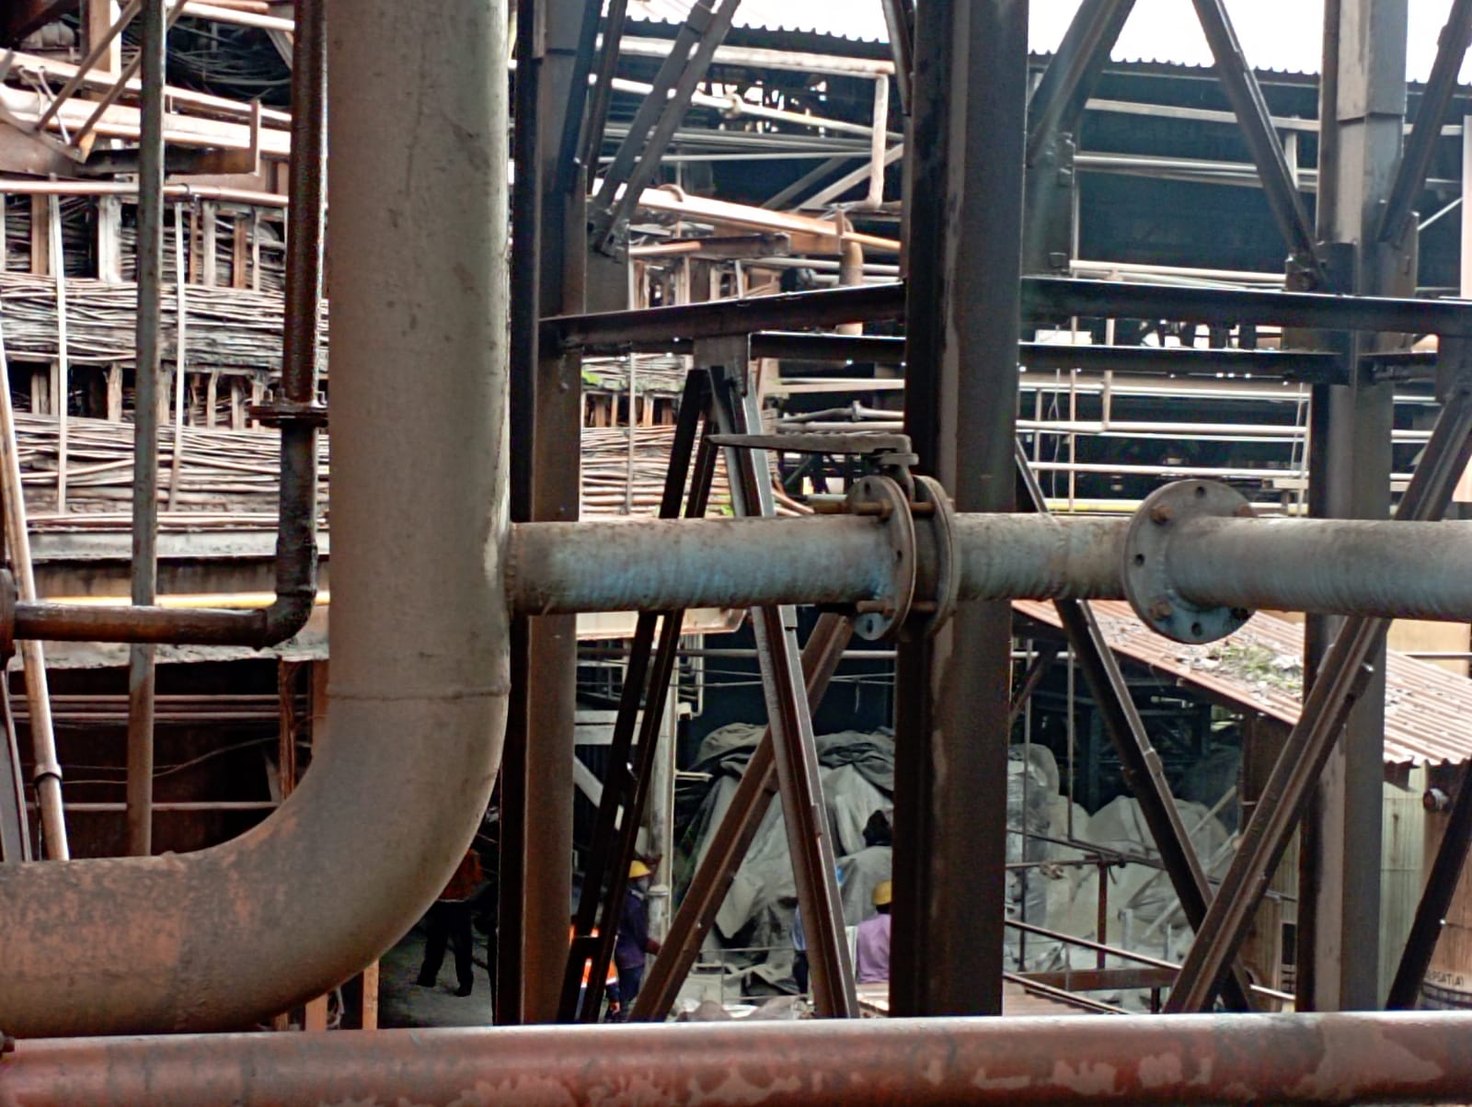

GCS inlet Valve

* + 1. Maintain water flow at 50-60M3/Hr in scrubber unit
    2. Ensure water drain tank is kept full always

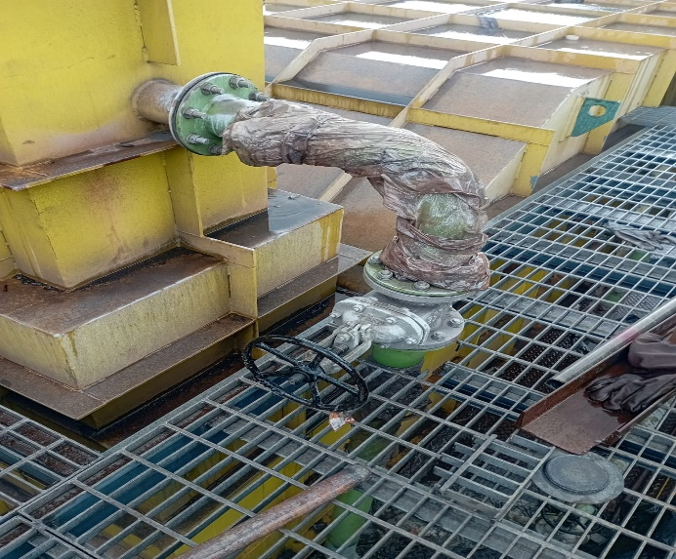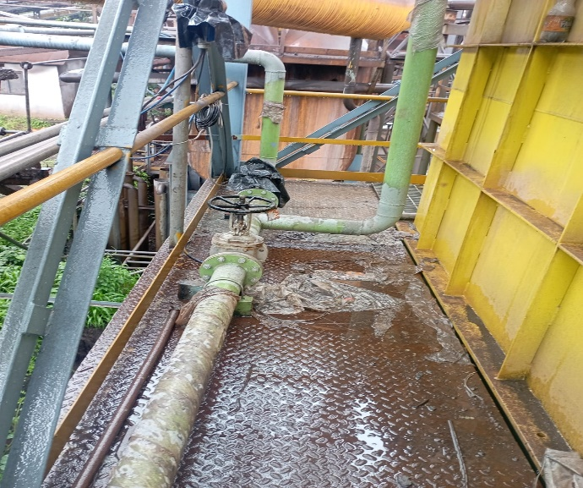

Cleaning valves

Cleaning valves

* + 1. After taking scrubber in line continuous monitoring of parameter form PLC to be ensured such as water flow, BF Gas DP, Moisture % and dust percentage level. As shown in below pic.

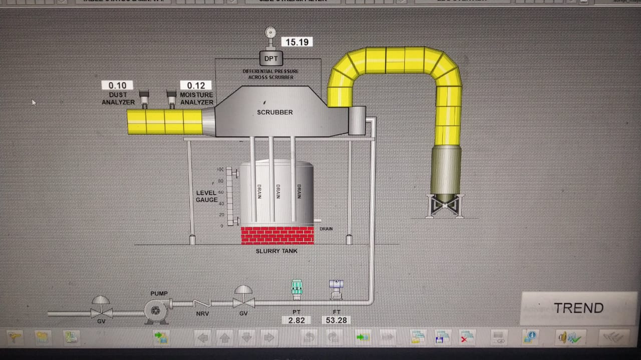

1. **Isolating the Scrubber Unit**
   * + 1. Water seal the HBS/GPH
       2. After water seal ensure continuous water flow
       3. Stop water flow to the scrubber unit by closing individual valves.
       4. If required steam purging to be carried and start subsequent relief valves

|  |  |  |
| --- | --- | --- |
| **Prepared By:**  Head – Production PID I | **Reviewed & Issued By:**  Management Representative | **Approved By:**  Head – Pig Iron Division |
| **Signature:** | **Signature:** | **Signature:** |
| **Date: 15.07.2022** | **Date: 15.07.2022** | **Date: 15.07.2022** |

|  |  |  |  |
| --- | --- | --- | --- |
| **Amendment Record** | | | |
| **Revision date** | **Manual Section ref. and para** | **Brief details of revision** | **New Revision No.** |
| 15.07.2022 | Work instructions for Scrubber unit | Change in format | 01 |